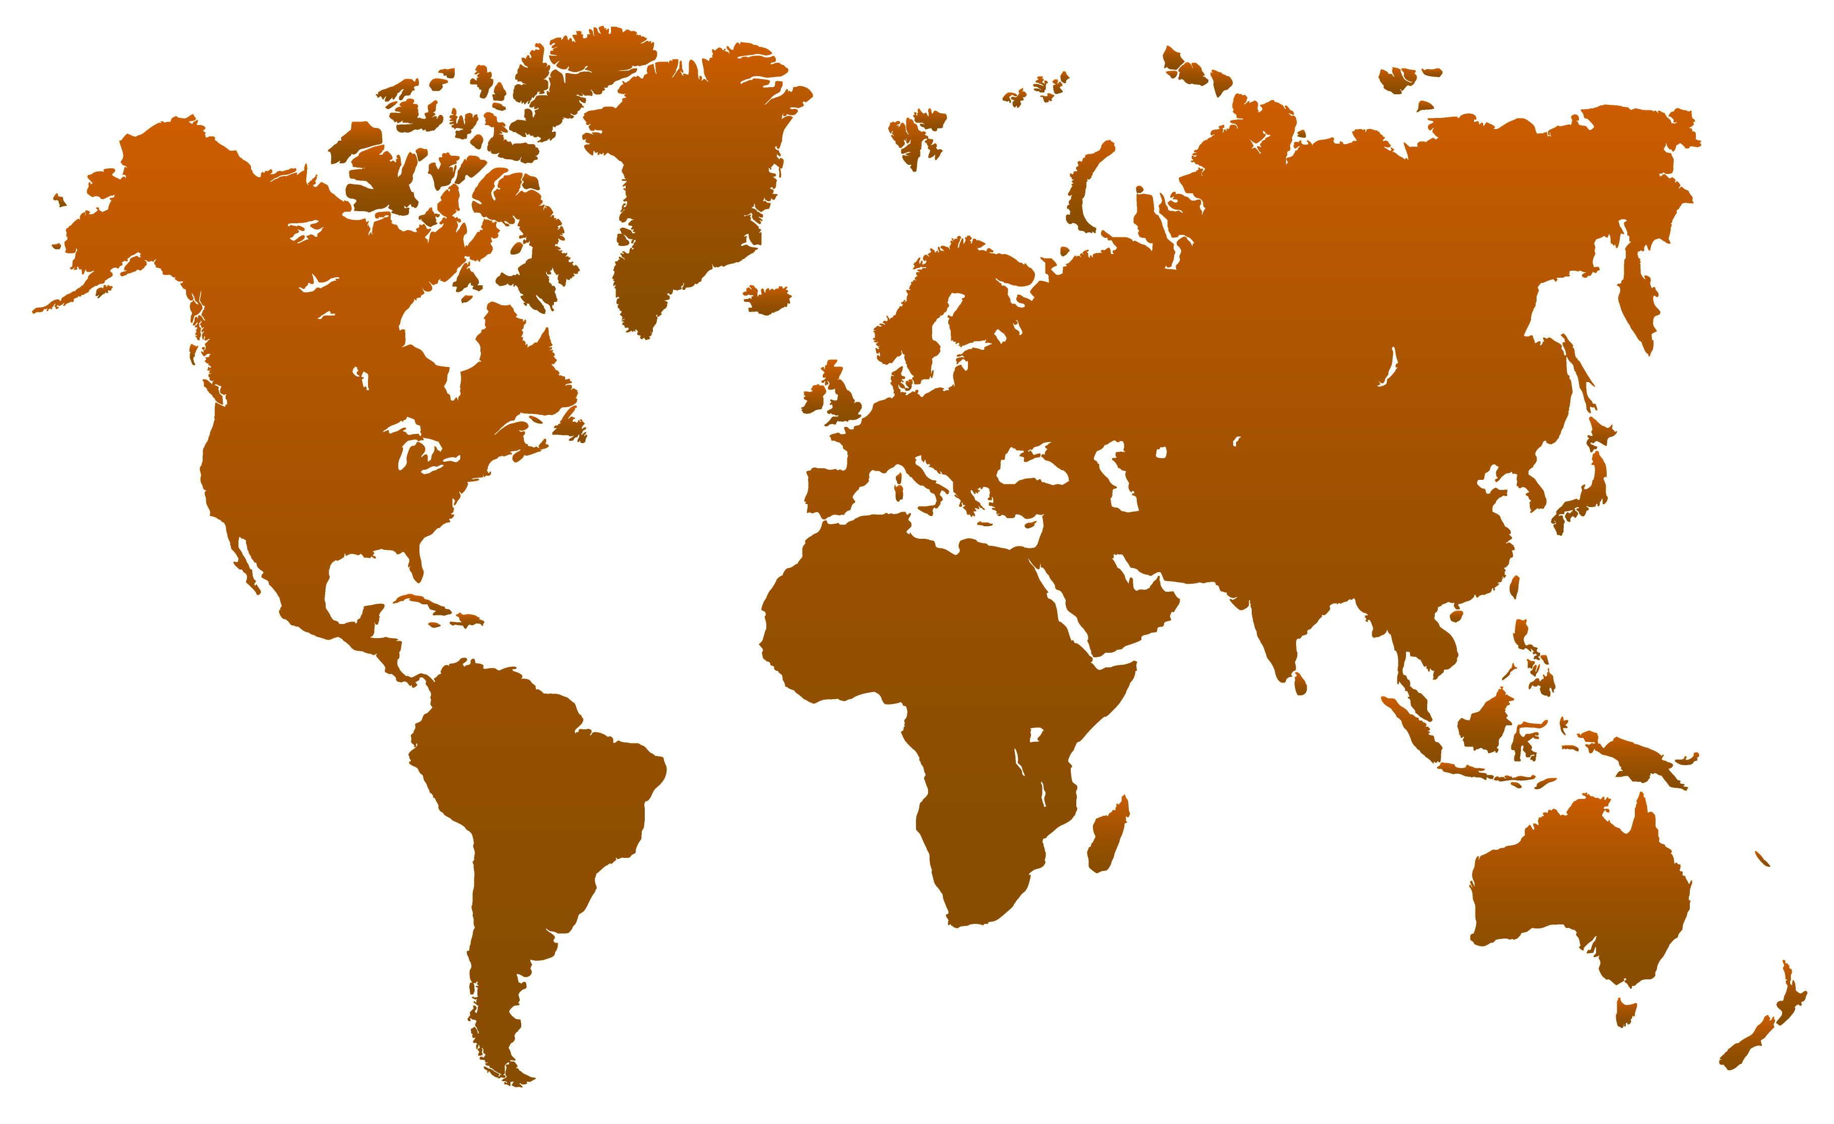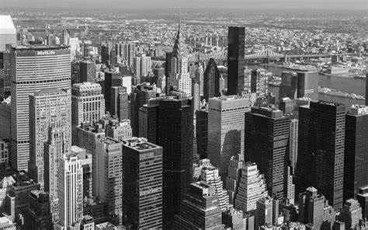

Logo

Signature text

Contact Us

+92-3058747886

shiningstars@gmail.com

Flat no3,

Township,

Lahore

Quote

Add Text

Add Text